The Burning Bush Church being
Christ Centered, Word Focused,
and Ministry Minded is committed
to reach, win, teach, and develop
the Body of Christ for the glory of Jesus Christ by:

Changing People

Changing Families

Changing Communities

Changing Nations

Worship Times

Sunday:

Worship Service: 8:30AM & 11:00AM
New Members Class: 10:00AM

Monday

Woman of Wisdom: 1st & 3rd 7:00PM
Brothers of Worship:2nd & 4th 7:00PM

Wednesday:
Bible Study

Morning: 10:00AM
Meditation: 6:30PM
Adult & Youth (TNT): 7:00PM

Saturday:

Prayer: 9:00AM
Shepherds Hour: 10:00AM

GREETER MINISTRY

Dr. David Denson Jr. Pastor/Founder

Interested in joining this ministry?
Contact: Bush administration office

14849 7th Street, Victorville, CA 92395
Phone: 760-241-6221
www.bushpower.org

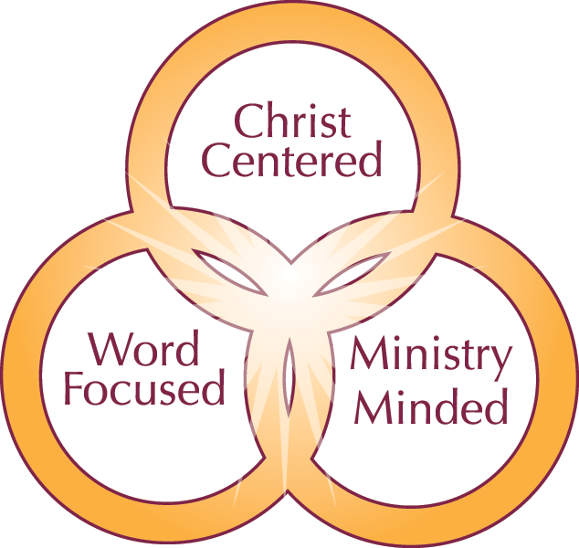

Greeter Ministry Objective/Purpose:

- The Greeter Ministry objective is to make every individual feel welcome!
- Whether you’re a first time guest or if you’re a long time member, greeters are here to make you feel “at home”, and welcomed.
- This ministry is a reflection of our Pastor and First Lady!
- Our purpose is to extend Love, Respect, and a Kind Spirit, from the time a person enters the front door.
- This aligns with the church mission statement of being Christ Centered, Word Focused, and Ministry Minded.

Scripture:
Hebrews 13:2
Be not forgetful to entertain strangers: for thereby some have entertained angels unawares.

One Place to Worship

One Place to Study

One Place to Serve

Qualifications for Membership:

- Must be a member of the Burning Bush Church and have completed New Member Classes.
- Must be a Tither
- Able to attend regularly scheduled greeter meetings.
- Must have a pleasant disposition.
- Friendly personality
- Approachable
- Warm Smile

