The Burning Bush Church being
Christ Centered, Word Focused,
and Ministry Minded is committed
to reach, win, teach, and develop
the Body of Christ for the glory of Jesus Christ by:

Changing People

Changing Families

Changing Communities

Changing Nations

Worship Times

Sunday:

Worship Service: 8:30AM & 11:00AM
New Members Class: 10:00AM

Monday

Woman of Wisdom: 1st & 3rd 7:00PM
Brothers of Worship:2nd & 4th 7:00PM

Wednesday:
Bible Study

Morning: 10:00AM
Meditation: 6:30PM
Adult & Youth (TNT): 7:00PM

Saturday:

Prayer: 9:00AM
Shepherds Hour: 10:00AM

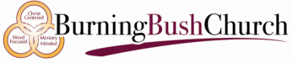

JUMBOTRON MINISTRY

Dr. David Denson Jr. Pastor/Founder

Interested in joining this ministry?
Contact: Bush administration office

14849 7th Street, Victorville, CA 92395
Phone: 760-241-6221
www.bushpower.org

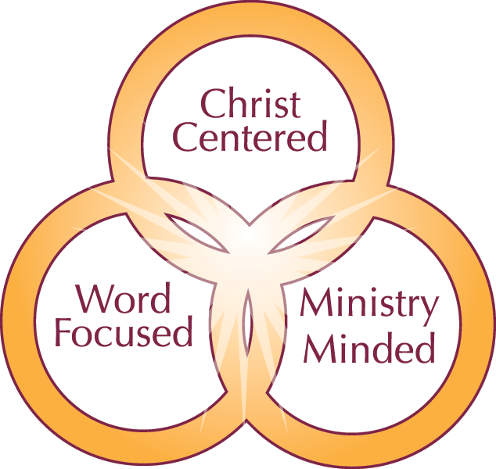

Jumbotron Ministry Objective/Purpose:

- The purpose of the Jumbotron Ministry is to provide computer and video presentation support to the Burning Bush Church during all activities where needed.
- This includes but is not limited to all worship services, prayer, drama productions (including rehearsals), and bible studies.

One Place to Worship

One Place to Study

One Place to Serve

Qualifications for Membership:

- Two years membership in the Burning Bush Church.
- A Tither and one who partners with our Man of God.
- Attention to detail is critical.
- Must be able to focus on the preacher or speaker with distractions all around and follow their verbal instruction.
- The ability to arrive at least 1 hour before scheduled activities to input scriptures and setup presentation.
- Typing speed of 50 wpm is a plus.
- Attend regularly scheduled monthly meetings

