The Burning Bush Church being
Christ Centered, Word Focused,
and Ministry Minded is committed
to reach, win, teach, and develop
the Body of Christ for the glory of Jesus Christ by:

Changing People

Changing Families

Changing Communities

Changing Nations

Worship Times

Sunday:

Worship Service: 8:30AM & 11:00AM
New Members Class: 10:00AM

Monday

Woman of Wisdom: 1st & 3rd 7:00PM
Man to Man: 2nd & 4th 7:00PM

Wednesday:
Bible Study

Morning: 10:00AM
Meditation: 6:30PM
Adult & Youth (TNT): 7:00PM

Saturday:

Prayer: 9:00AM
Shepherds Hour: 10:00AM

YOUTH MINISTRY

Dr. David Denson Jr. Pastor/Founder

Interested in joining this ministry?
Contact: Bush administration office

14849 7th Street, Victorville, CA 92395
Phone: 760-241-6221
www.bushpower.org

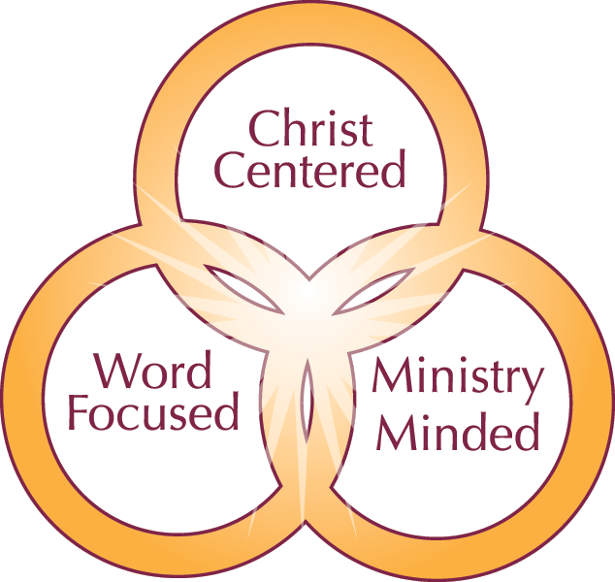

Youth Ministry Objective/Purpose:

- We believe that the children are the heritage that God has given with the commandment to be fruitful and multiply.
- With that mandate we are admonished to:
“…raise them in the fear (reverence) nurture and admonition of the Lord”.
(Ephesians 6:4b KJV)
“Train up a child in the way he should go, And when he is old he will not depart from it.”
Proverbs 22:6 KJV
- As a ministry to the youth of the Burning Bush Church, we commit to assist in the spiritual development of a generation of young people who at a young age will reverence God and know early their worth in His eyes, as well as, their inherent responsibility to love, honor and represent Him all the days of their life.
- “Even a child is known by his deeds, whether what he does is pure and right.”
Proverbs 20:11 KJV

One Place to Worship

One Place to Study

One Place to Serve

Qualifications for Membership:

- All children of appropriate age are welcome.
- Spiritual Gifts Required:
- (To work as leader in ministry)
- Administration, Helps, Giving, Hospitality, Knowledge, Teaching
- (To Teach or Lead):
- One must love teaching and taking part in the growth and development of all young people and possess a heart to serve them.

- Toddlers: 2-5 years old
- Youth: 6-13 years old
- Open 2nd, 3rd, 4th Sunday
  - 11AM only
- *No Youth/Toddler church
  - 1st or 5th Sunday
- TNT (Teaching, Nurturing, Transforming)
  - Every Wednesday at 7PM
- Youth Choir Rehearsal
  - 2nd & 4th Wednesday

