The Burning Bush Church being
Christ Centered, Word Focused,
and Ministry Minded is committed
to reach, win, teach, and develop
the Body of Christ for the glory of Jesus Christ by:

Changing People

Changing Families

Changing Communities

Changing Nations

Worship Times

Sunday:

Worship Service: 8:30AM & 11:00AM
New Members Class: 10:00AM

Monday

Woman of Wisdom: 1st & 3rd 7:00PM
Brothers of Worship:2nd & 4th 7:00PM

Wednesday:
Bible Study

Morning: 10:00AM
Meditation: 6:30PM
Adult & Youth (TNT): 7:00PM

Saturday:

Prayer: 9:00AM
Shepherds Hour: 10:00AM

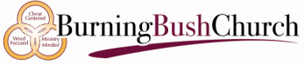

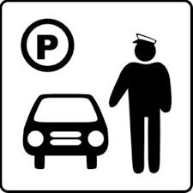
PARKING LOT MINISTRY

Dr. David Denson Jr. Pastor/Founder

Interested in joining this ministry?
Contact: Bush administration office

14849 7th Street, Victorville, CA 92395
Phone: 760-241-6221
www.bushpower.org

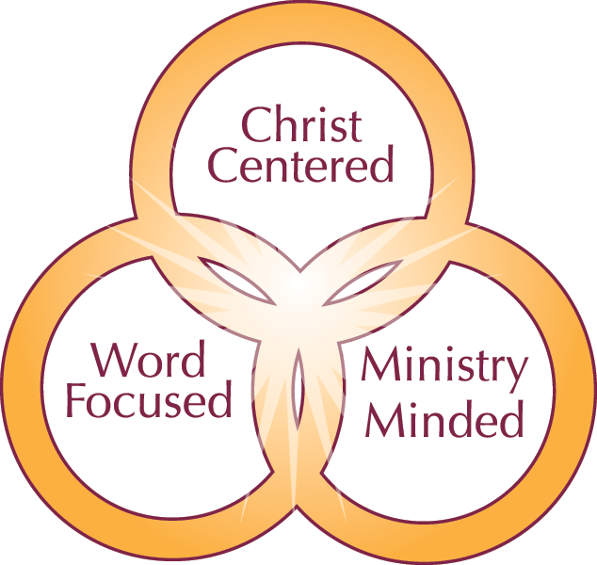

Parking Lot Ministry Objective/Purpose:

- Greet members and guests with a warm welcome while assisting them with parking.
- Patrol parking lots during service hours to maintain perimeter security.

Scripture:
Romans 16:16
Salute one another with an holy kiss. The churches of Christ salute you.

One Place to Worship

One Place to Study

One Place to Serve

Qualifications for Membership:

- Member of the Burning Bush Church
- Completion of New Members Classes
- Regular attendance and a willingness to be developed.
- The ability to stand and/or walk for extended periods of time is also required.
- Ability to support in extreme temperatures.

