The Burning Bush Church being
Christ Centered, Word Focused,
and Ministry Minded is committed
to reach, win, teach, and develop
the Body of Christ for the glory of Jesus Christ by:

Changing People

Changing Families

Changing Communities

Changing Nations

Worship Times

Sunday:

Worship Service: 8:30AM & 11:00AM
New Members Class: 10:00AM

Monday

Woman of Wisdom: 1st & 3rd 7:00PM
Brothers of Worship:2nd & 4th 7:00PM

Wednesday:
Bible Study

Morning: 10:00AM
Meditation: 6:30PM
Adult & Youth (TNT): 7:00PM

Saturday:

Prayer: 9:00AM
Shepherds Hour: 10:00AM

BOW MINISTRY

Dr. David Denson Jr. Pastor/Founder

Interested in joining this ministry?
Contact: Bush administration office

14849 7th Street, Victorville, CA 92395
Phone: 760-241-6221
www.bushpower.org

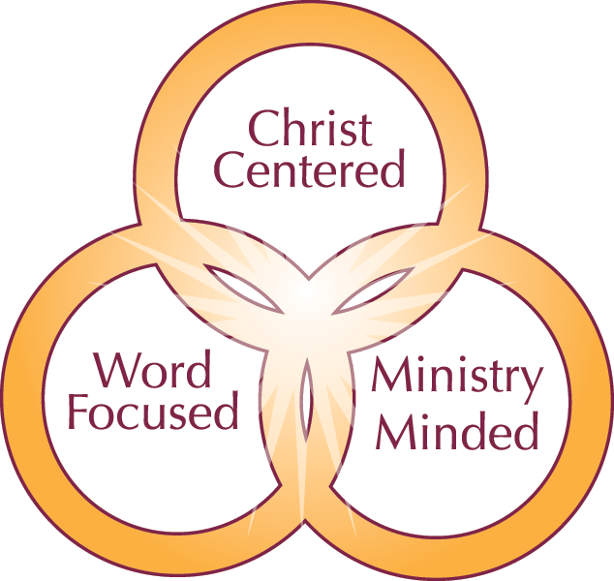

BOW Ministry Objective/Purpose:

- The Men’s Ministry is aligned with the vision and values set forth by Dr. David Denson Jr.
- We are inspired by the Holy Spirit to equip and guide men to become Christ like leaders in their homes, churches, communities and careers.
- We emphasize the principal of reconciliation by teaching men the power of prayer, praise and worship.
- We encourage men to model their lifestyle after Jesus Christ.
- The purpose of the Men's Ministry is to enlighten the men of the Burning Bush Church of the desire, commitment, and spirit of servitude required to assist Pastor Denson in accomplishing the vision God has given him for our church body.
- We are here to help men understand "The Vision of this House" and to become an active member in ministry.

One Place to Worship

One Place to Study

One Place to Serve

Qualifications for Membership:

- Any man desiring a closer walk with God.
- Attend bi-monthly bible study/fellowship

Psalm 27:3-6
³ Though an host should encamp against me, my heart shall not fear: though war should rise against me, in this [will] I [be] confident.
⁴ One [thing] have I desired of the LORD, that will I seek after; that I may dwell in the house of the LORD all the days of my life, to behold the beauty of the LORD, and to enquire in his temple.
⁵ For in the time of trouble he shall hide me in his pavilion: in the secret of his tabernacle shall he hide me; he shall set me up upon a rock.
⁶ And now shall mine head be lifted up above mine enemies round about me: therefore will I offer in his tabernacle sacrifices of joy; I will sing, yea, I will sing praises unto the LORD.

