The Burning Bush Church being
Christ Centered, Word Focused,
and Ministry Minded is committed
to reach, win, teach, and develop
the Body of Christ for the glory of Jesus Christ by:

Changing People

Changing Families

Changing Communities

Changing Nations

Worship Times

Sunday:

Worship Service: 8:30AM & 11:00AM
New Members Class: 10:00AM

Monday

Woman of Wisdom: 1st & 3rd 7:00PM
Man to Man: 2nd & 4th 7:00PM

Wednesday:
Bible Study

Morning: 10:00AM
Meditation: 6:30PM
Adult & Youth (TNT): 7:00PM

Saturday:

Prayer: 9:00AM
Shepherds Hour: 10:00AM

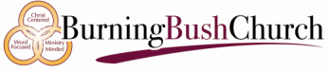

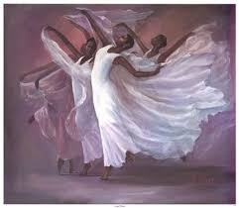

DANCE MINISTRY

Dr. David Denson Jr. Pastor/Founder

Interested in joining this ministry?
Contact: Bush administration office

14849 7th Street, Victorville, CA 92395
Phone: 760-241-6221
www.bushpower.org

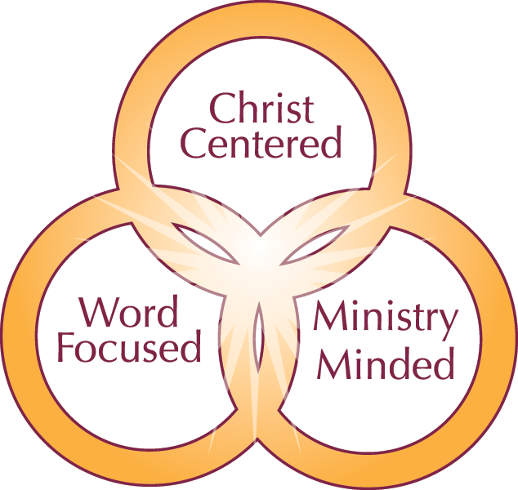

Dance Ministry Objective/Purpose:

- The Praise Dance Ministry is based on the vision of Dr. David Denson Jr.
- It is our mission to evoke free and open praise of God.
- We are a ministry that is Christ Centered, Word Focused, and Ministry Minded.
- We minister to Change People, Change Families, Change Communities, and now Change Nations.

Scripture:
Psalms 149:3
Let them praise his name with dancing and make music to him with timbrel and harp.

One Place to Worship

One Place to Study

One Place to Serve

Qualifications for Membership:

To use synchronized motion inspiring a spiritually emotional response, that conveys a sacred connection between oneself and God.

Qualifications for Membership
Youth (6-13) and Adults – One year membership in Burning Bush Church and attendance in prayer and bible study
Youth and Children (2-5) may join at any time.

Physical Requirements:
Because of the physical nature of this ministry, the following are some requirements that should be met to have success in the dance ministry.

Body Coordination: The ability to coordinate the movement of your arms, legs, and torso together when the body is in motion.

Stamina: The ability to exert yourself physically over long periods of time without getting overly winded.

Flexibility: The ability to bend, stretch, twist or reach with your body, arms, and/or legs.

Trunk Strength: The ability to use your abdominal and lower back muscles to support part of the body repeatedly or continuously over time without becoming too fatigued.

Body Equilibrium: The ability to keep or regain your body balance or stay upright when in an unstable position.

Having an ear for music and the ability to count music is helpful.

